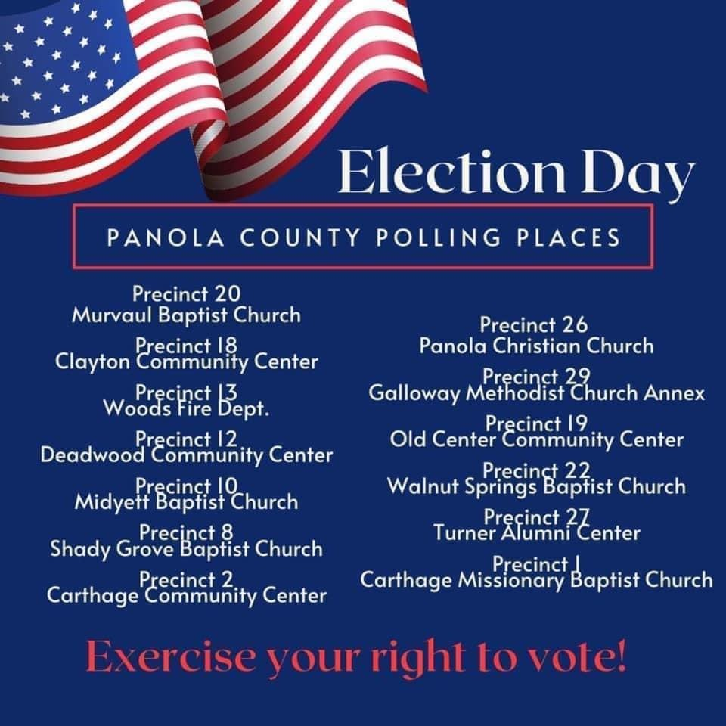

YOUR VOTE IS YOUR VOICE

Precinct 10

Midyett Baptist Church

601 CR 326

DeBerry, Tx

Precinct 12

Deadwood Community Center

752 CR 445

Carthage, Tx

Precinct 13

Woods VFD

208 CR 425

Tenaha, Tx

Precinct 14

Gary City Hall

2607 FM 999

Gary, TX

Precinct 18

Clayton Community Center

4580 HWY 315

Carthage, Tx

Precinct 19

Old Center Community Center

7093 FM 699

Tenaha, Tx

Precinct 20

Murvaul Baptist Church

3390 FM 10

Carthage, Tx

Precinct 22

Walnut Springs Baptist Church

1806 FM 1186

DeBerry, Tx

Precinct 26

Panola Christian Church

7881 FM 2517

Carthage, Tx

Precinct 27

Turner Alumni Center

1023 MLK BLVD

Carthage, Tx

Precinct 28

Carthage Civic Center

1702 S Adams St.

Carthage, Tx

Precinct 29

Galloway Methodist Church

217 CR 4562

Carthage, Tx

Early Voting Location

Elections Office

110 S Sycamore St. Room 100

Carthage, Tx

Precinct 1

Carthage Missionary Baptist Church

916 W. Sabine St.

Carthage, Tx

Precinct 2

Carthage Community Center

200 Park Dr.

Carthage, Tx

Precinct 3

Beckville Community Center

225 S Washington

Beckville, Tx

Precinct 5

Mt. Zion Baptist Church

5209 FM 959

Beckville, Tx

Precinct 7

Comm. 4 VFD Sub Station

254 CR 3151

DeBerry, Tx

Precinct 8

Shady Grove Baptist Church

138 CR 314

DeBerry, Tx

Precinct 9

Community 4 VFD

112 FM 9

Waskom, Tx

PANOLA COUNTY POLLING PLACES

Election Day